# Raspberry Pi Introduction

Written by Mark Webster and ??

**SUMMARY DESCRIPTION**

Learn to run programs on a raspberry pi

## Introduction

The Raspberry Pi is a single board computer-- an entire computer system on one board the size of a deck of playing cards. It is not a microcontroller because the Raspberry Pi requires an operating system that must boot up before running any program. It is a general purpose computer since it runs many types of programs, including a web browser, wordprocessor, compilers, and games.

A Raspberry Pi contains several modules even in its small size. It has HDMI output, an SD card for the operating system and software, a GPU for graphics acceleration, Ethernet and wifi for internet access, bluetooth, four USB 2.0 plugs, a 3.5mm headphone jack, and some parts not on a regular desktop or laptop computer. It has a display interface for touchscreens, a camera interface, and GPIO pins (general purpose IO pins) to connect to external devices. It does not have analog input pins like an Arduino. The Raspberry Pi can run different operating systems, although the default and most common is a version of Linux called Raspbian.

The Raspberry Pi has an ARM cpu which is less expensive and smaller than Intel processors, however not all software has been compiled to support ARM processors.

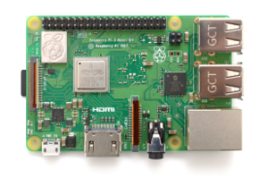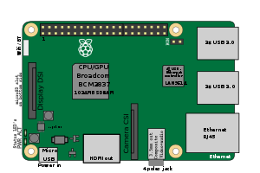

## Download and Install

The Raspbian operating system is a version of Linux based on the lightweight LXDE version of Linux. Raspbian. can be downloaded for free from:

<https://www.raspberrypi.org/downloads/raspbian/>

Usually people download the full Raspbian with application software unless the Raspberry Pi will be run as a headless server.

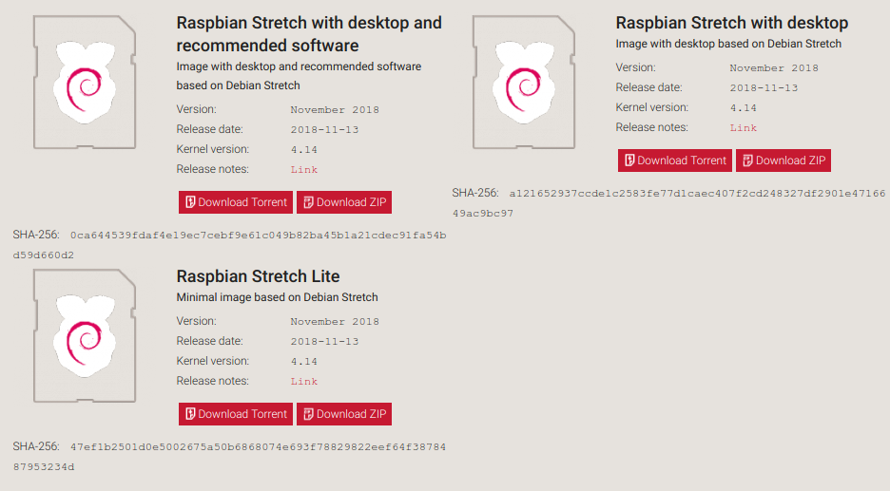

The operating system is downloaded to some laptop or desktop computer and unzipped using 7-Zip (windows), Unarchiver (mac), Unzip (Linux). The resulting *.img file must be copied to a microSD card. The faster the microSD card, the faster the operating system will perform.

The operating system must be put on a boot disk. This is a simple operation using programs designed to make boot disks.

On Linux, the default “Disks” program has the menu option “Restore Disk Image” which creates a bootable SD card.

On all systems (Windows, Linux, Mac) the free program “Etcher” <https://www.balena.io/etcher/>

will create a bootable SD card.

## Configuration (raspi-config)

When the new Raspbian SD card boots up for the first time, it will walk the new user through the configuration process. For example, by default Raspbian assumes the computer is in the UK and will have an incorrect keyboard for computers in the USA.

At any time, a user can change configuration settings, either from the GUI or the command line.

The GUI method is to use the “Raspberry Pi Configuration” submenu on the Preferences listing.

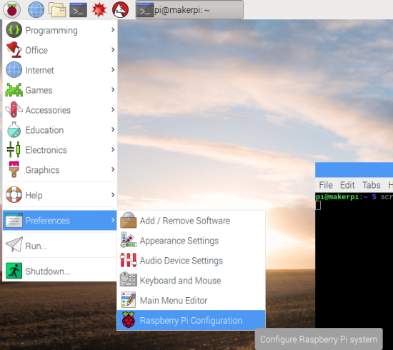

Which brings up the dialog to set various options such as changing the password. It lets you set the keyboard to USA not UK.

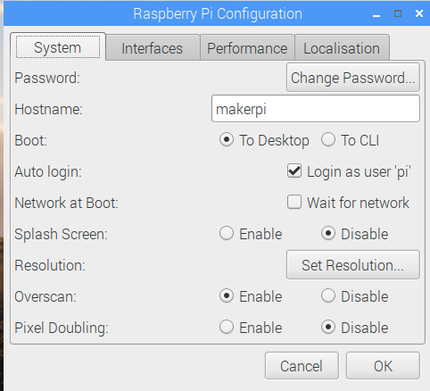

The command line approach is to open a terminal window and type

“sudo raspi-config”

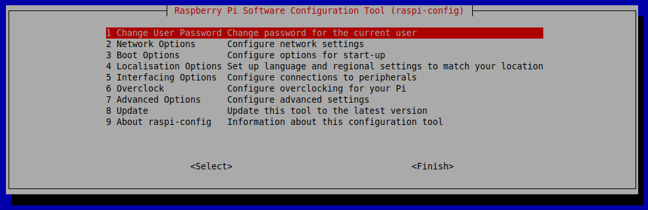

The command line raspi-config does not use a mouse, just the tab key to move between options and enter key to select an option. The raspi-config utility can be used remotely over ssh for headless Raspberry Pi configuration.

## Desktop Applications

There are many default applications that are installed with a full Raspbian system. These include the Microsoft Office equivalent of Libreoffice. It also includes the open source web browser Chromium. Several editors and Python interpreters are installed by default as well.

Perhaps the most unusual is a free version of Mathematica which costs hundreds of dollars per year on a laptop or desktop computer.

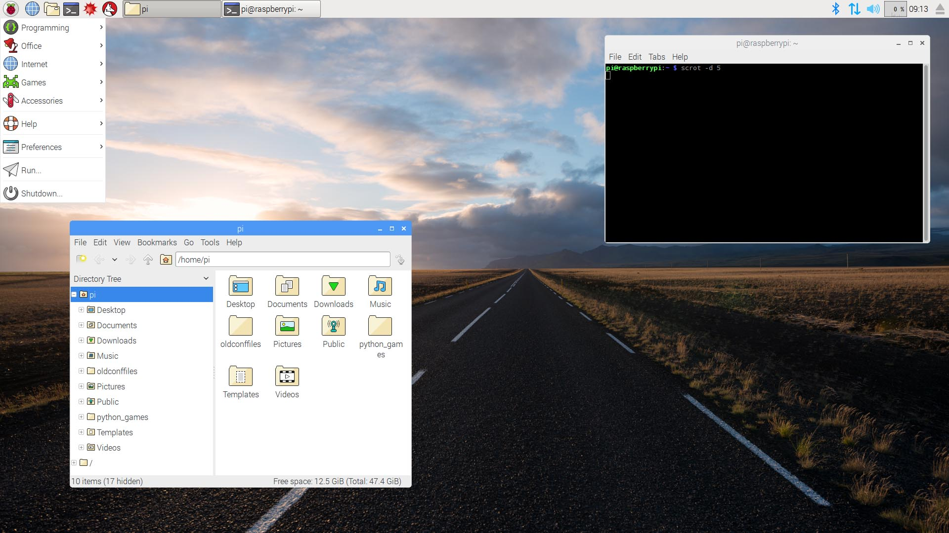

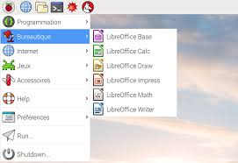

## Programming

The default Raspbian include Python2 and Python3, as well as the kid’s visual programming language Scratch. Raspbian includes the default editor “Nano” but most programmers install their own favorite code editor, such as Vim or Geany.

Raspbian does include the game Minecraft, but there are countless free and pirated games available for the Raspberry Pi.

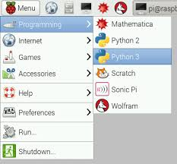

## Terminal and Command Line

Linux is a version of Unix which was created in 1971, long before computers had mice, long before the graphical interface of Windows or MacOS. Unix evolved into a powerful operating system long before the Macintosh. In those early days all commands were typed in using a keyboard in a terminal window. These old and powerful commands still exist in the graphical versions of Linux and re reached by opening a terminal window and typing away.

Some common commands are: ls, dir, rm, cd, cal, cat, clear, nano.

Most commands have a help option, and all have a manual found by typing “man command”.

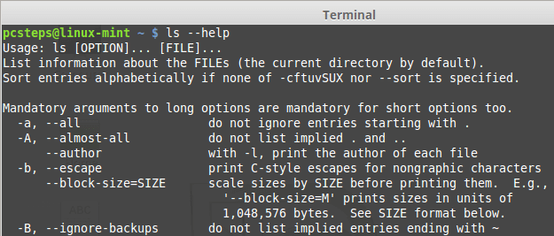

## Exercises

### Exercise 1:

Boot up Raspberry pi to desktop. Run Libreoffice writer. Write a small document, then save the file. Open the file manager, find the file, and double click it to open the file. Delete the file when done.

### Exercise 2:

open a terminal window. Edit a python file using nano. Execute python file with python3 filename

Edit the file with the nano text editor.

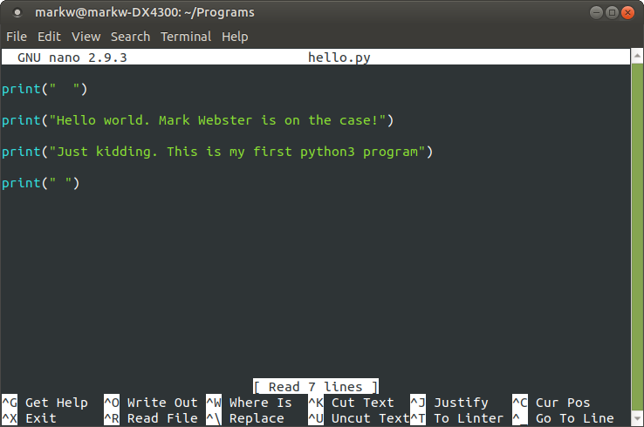

Then exit and run the program from the command line with python3.

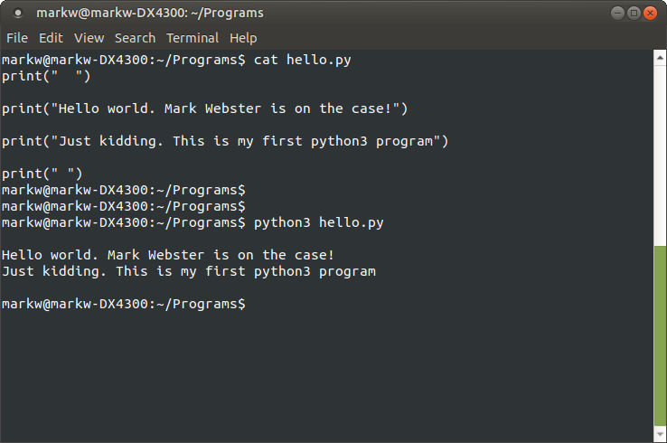

### Exercise 3:

Connect to a headless Raspberry Pi using RealVNC. Then SSH into the same headless raspberry pi. Copy file to and from using scp. (Filezilla is a graphical option)

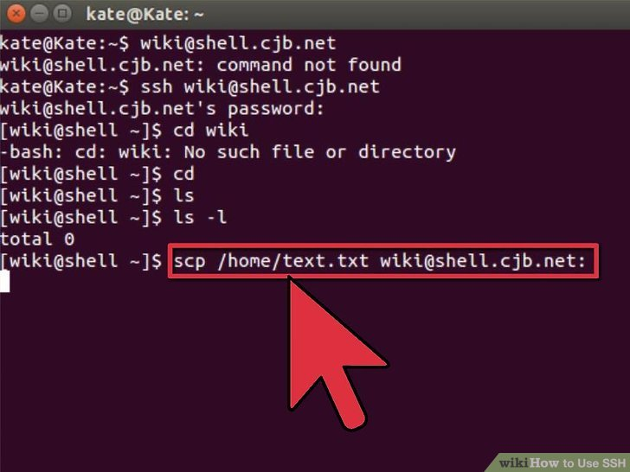

Can also use RealVNC for a graphical remote desktop.

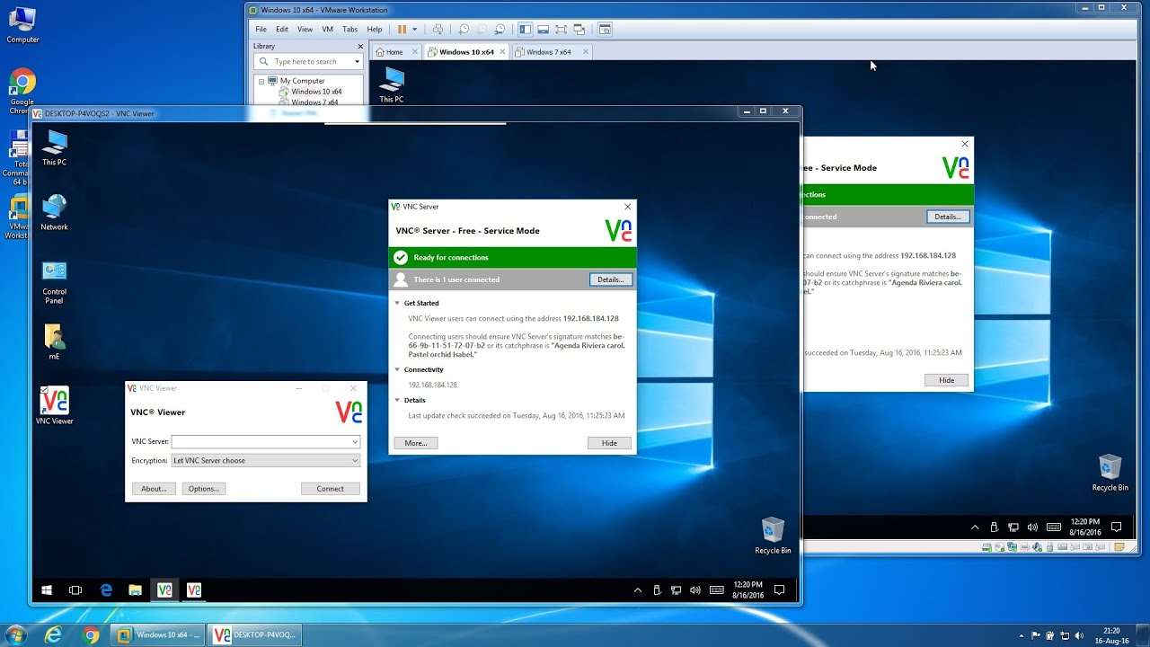

Can use Filezilla for graphical file transfer.

